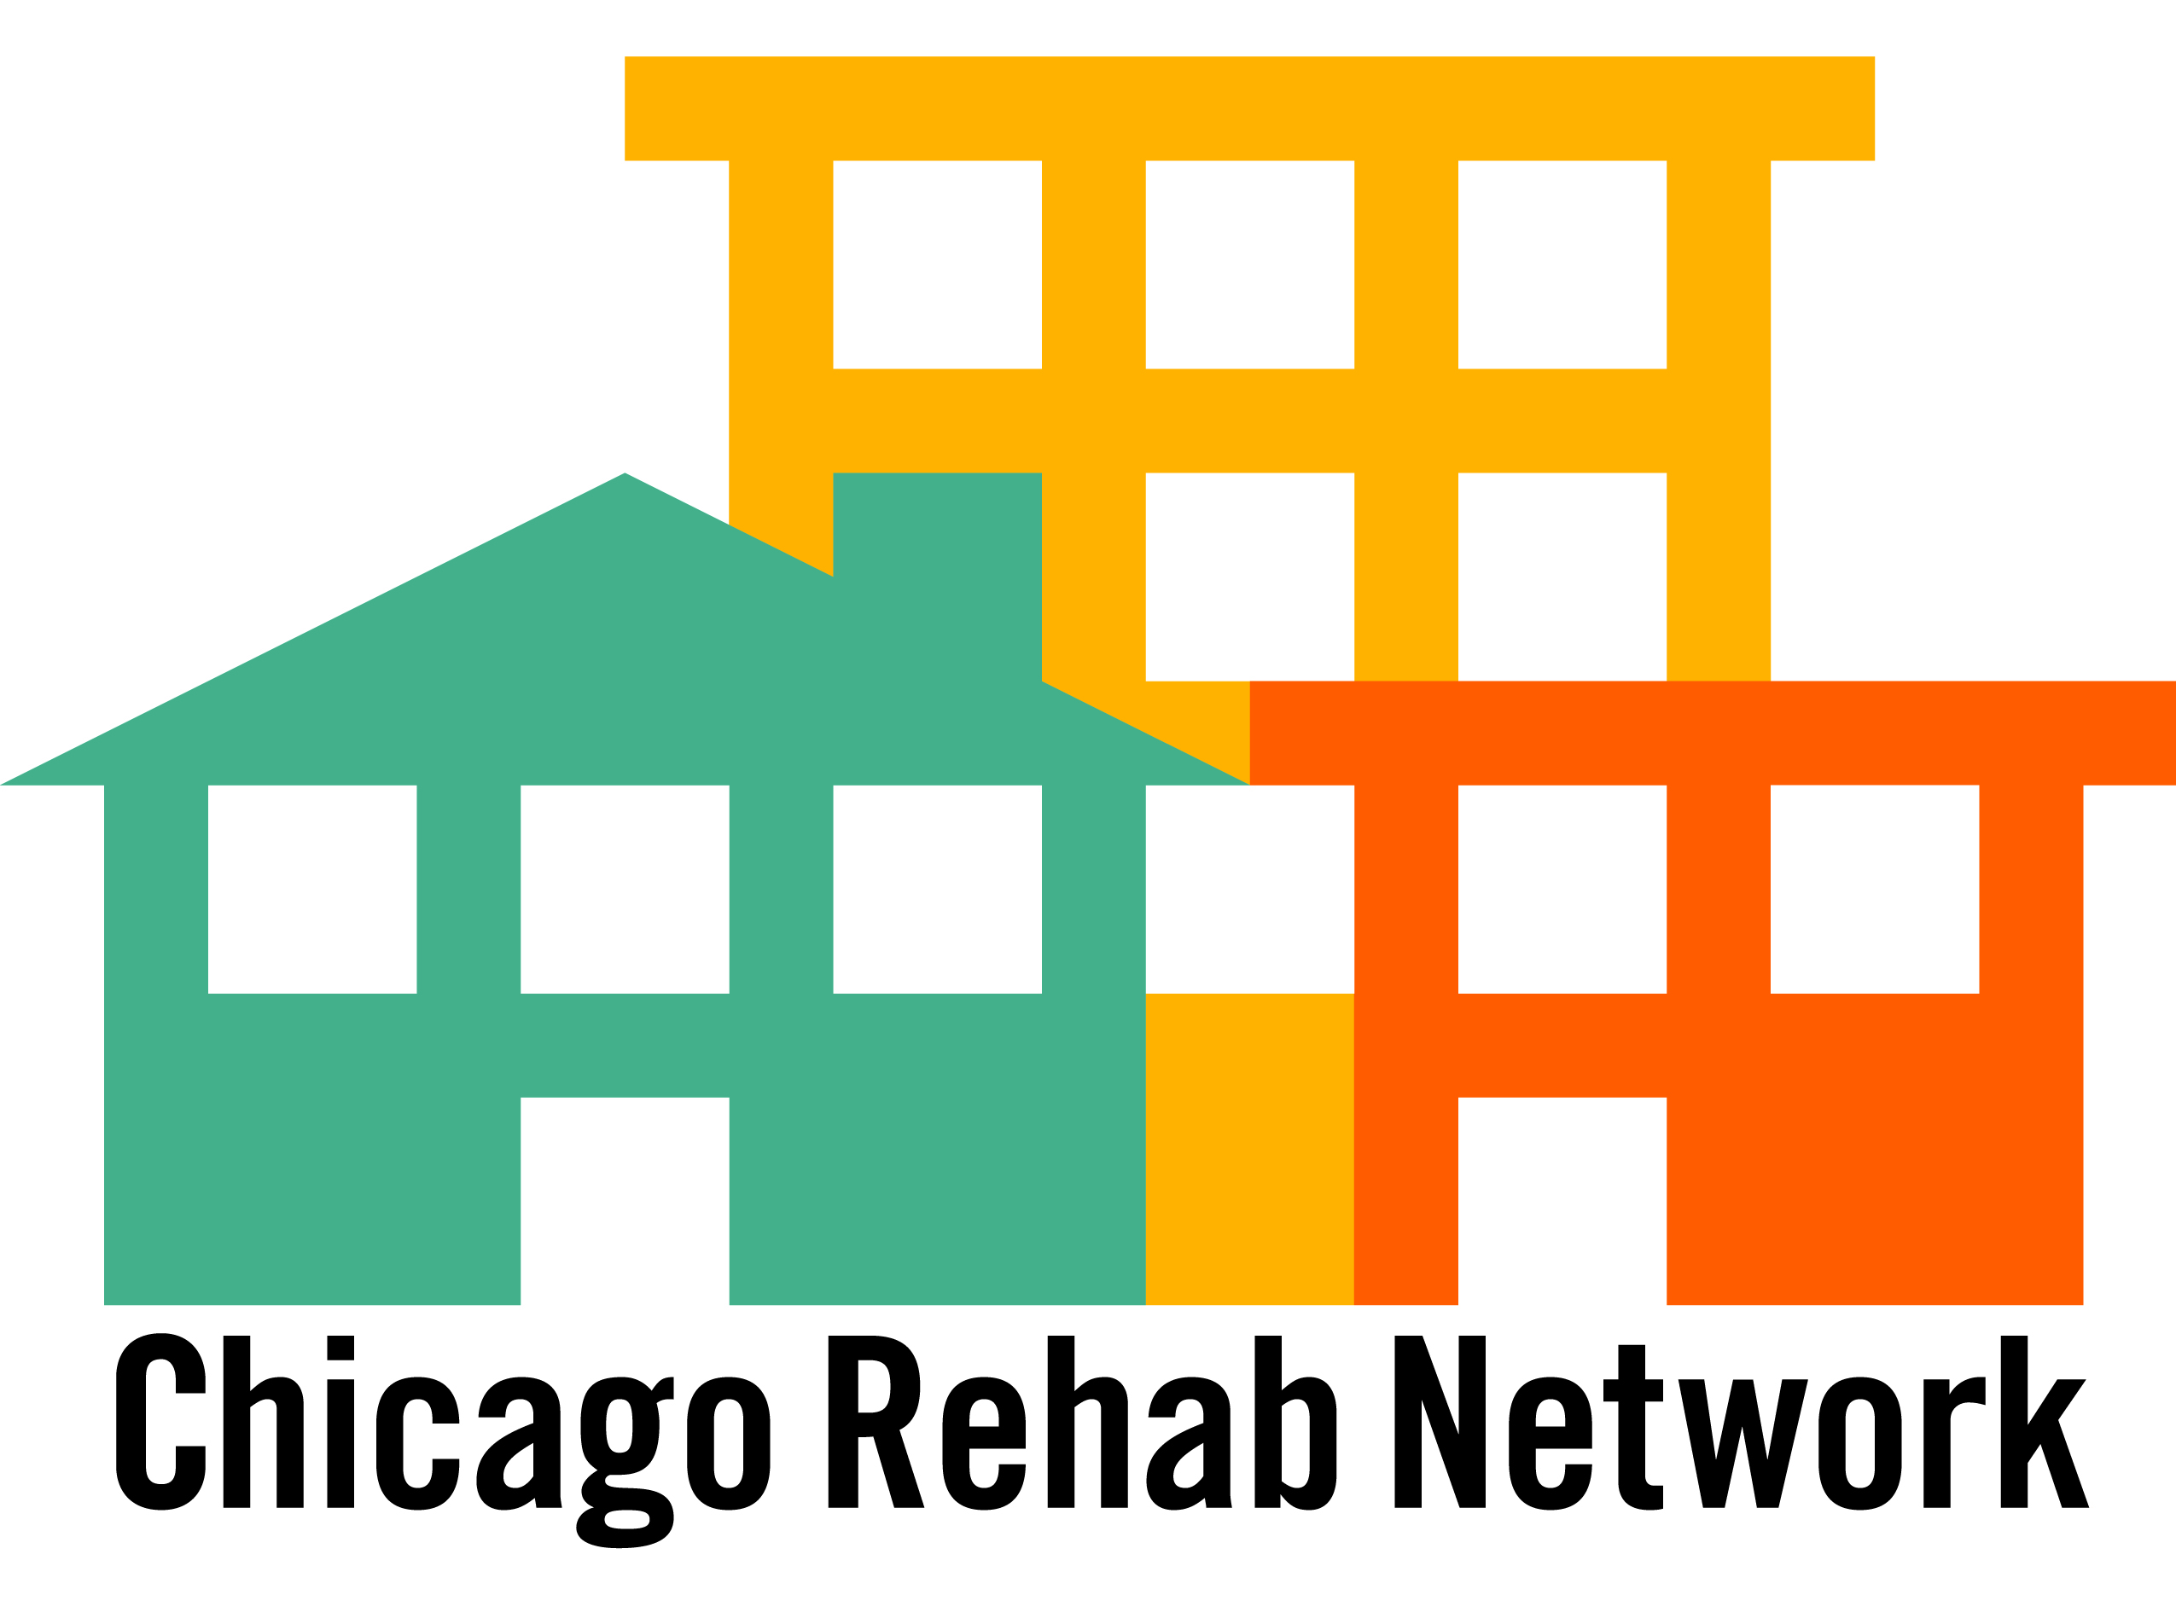

FROM: Kevin Jackson, Chicago Rehab Network and CRN Board Directors

RE: Testimony to Committee on Housing and Real Estate - Foreclosures

DATE: March 25, 2008

***********************************************************************

We appreciate the opportunity to comment to this Committee on the foreclosure crisis.
A key factor that must not be ignored is the overinflated housing appraisals and prices that have been well documented – especially as it has relates to housing cost burden. The real estate boom in Chicago resulted in a push and pull effect – many were pushed out of rental housing that was too costly, lured by promises that homeownership – at any cost – was a more secure housing solution. While we all await federal guidelines and resources to revamp the housing sector, all of us should reflect on the old physicians’ ethic of “first, do no harm”. Too often housing policy has leaned towards a belief that upper income market housing would “lift all tides” in a neighborhood. This current economic tornado challenges that viewpoint. Spoken more plainly, just because one can qualify for a $350,000 home – doesn’t mean one can afford that home. And the risk one family takes in doing so affects the entire community.

The impact of this situation on our work in community development cannot be overstated. We are concerned that the assets we’ve built together are now threatened and we should do all that we can to mitigate this growing instability. The community development field is well-positioned to contribute capacity, commitment, and broad stakeholder relationships to a unified effort.

There are strong federal proposals out of Congress being developed to address this crisis at the servicer, financer, and consumer levels. We expect significant resources will be coming to Illinois and Chicago for foreclosure mitigation and recapture of foreclosed properties. Our greatest hope is that a significant portion of these properties be protected from blight and demolition and be targeted for affordable housing.

Our leadership has established a set of principles to guide our philosophy of stabilizing neighborhoods:

- Nonprofits have the framework and experience to put families back into these homes given sufficient resources, with a careful eye towards both family and community sustainability.

- Foreclosed properties should become affordable dwellings and not be allowed into the speculative market.

- A plethora of housing strategies including full ownership, land trust, lease-to-purchase models, and rental must be utilized.

- Units must be packaged to nonprofits in such a way to make management and rehab cost-efficient.

- Subsidy at several levels will be required at amounts that are less than required for creating new units.

Community development corporations can be partners with the City to prevent the spread of abandoned buildings while providing badly needed affordable, quality housing. While we completely understand that it is the servicers that need to be negotiated with, we do believe that together we can devise some solutions.

Like in other economic crisis’, capital will soon be flowing to seek balance in the financial markets. To the extent the City Council will be involved in setting policy to direct that capital, we ask that you consider our principles and craft solutions that will “do no harm”.

Foreclosure Solution Scenarios

Three segments of households:

- Early foreclosure: Homeowner can pay if the mortgage interest level does NOT reset and is made fixed rate or other remediation is negotiated with lender.
- Late foreclosure: Homeowner is in imminent foreclosure = cannot pay mortgage payment but still in home. Notices of default sent.
- Foreclosed home: Homeowner leaving/gone. Home is through foreclosure process. Unit will be vacant.

Strategies per segment:

- Early foreclosure: City meets with banks holding the majority of loans to keep loans from resetting (or renegotiate terms) so family can stay in home.

City, financial institutions, counseling agencies, and IHDA offering “expos” to provide homeowners in crisis with information and linkage to resources. Current federal policies and funds flowing to increase massive demand for foreclosure counseling. These homeowners are actively seeking solutions.

City might consider an escrow model where household can continue to pay mortgage at pre-reset level but forego paying increase while predatory practices are investigated.

- Late Foreclosure: With goal being to keep family housed and prevent negative impact on community from unit being boarded up, process is needed to identify these homes and offer redevelopment options.

Households can be identified through Notice of Default postings and with targeted marketing.

Considerations
  - Pricing must be negotiated as appraisal processes have resulted in overinflated values. A three-appraisal process could be required to re-set home values to the market.
  - Lenders and servicers need incentives to take losses and transfer properties which may require city, state and/or federal legislation.
  - Families may need relocation services as gap may be too large in some markets.

This segment can be targeted to transferring ownership of home via deed in lieu or other such mechanism to CDC which would be responsible for determining appropriate ownership, management, and lease agreements.

Subsidy would be provided to the CDC buyer and or owner with restrictions on the property.

- Foreclosed Home: Homes already vacant require a broad comprehensive purchase/rehab strategy that would put the unit back into the community as an affordable unit.

Considerations:
  - A systemic process is needed to intervene in the foreclosure auction process that would allow for either a) government bodies to take ownership and transfer properties or b) to give nonprofits the ability to purchase homes whether through an acquisition pool or legal priority.
  - Scattered site management and probable rehab of some properties will require sufficient number of units, capital, and operating funds to be successful.
  - Lenders/investors should be incentivized to transfer pools of homes by geography where possible.

