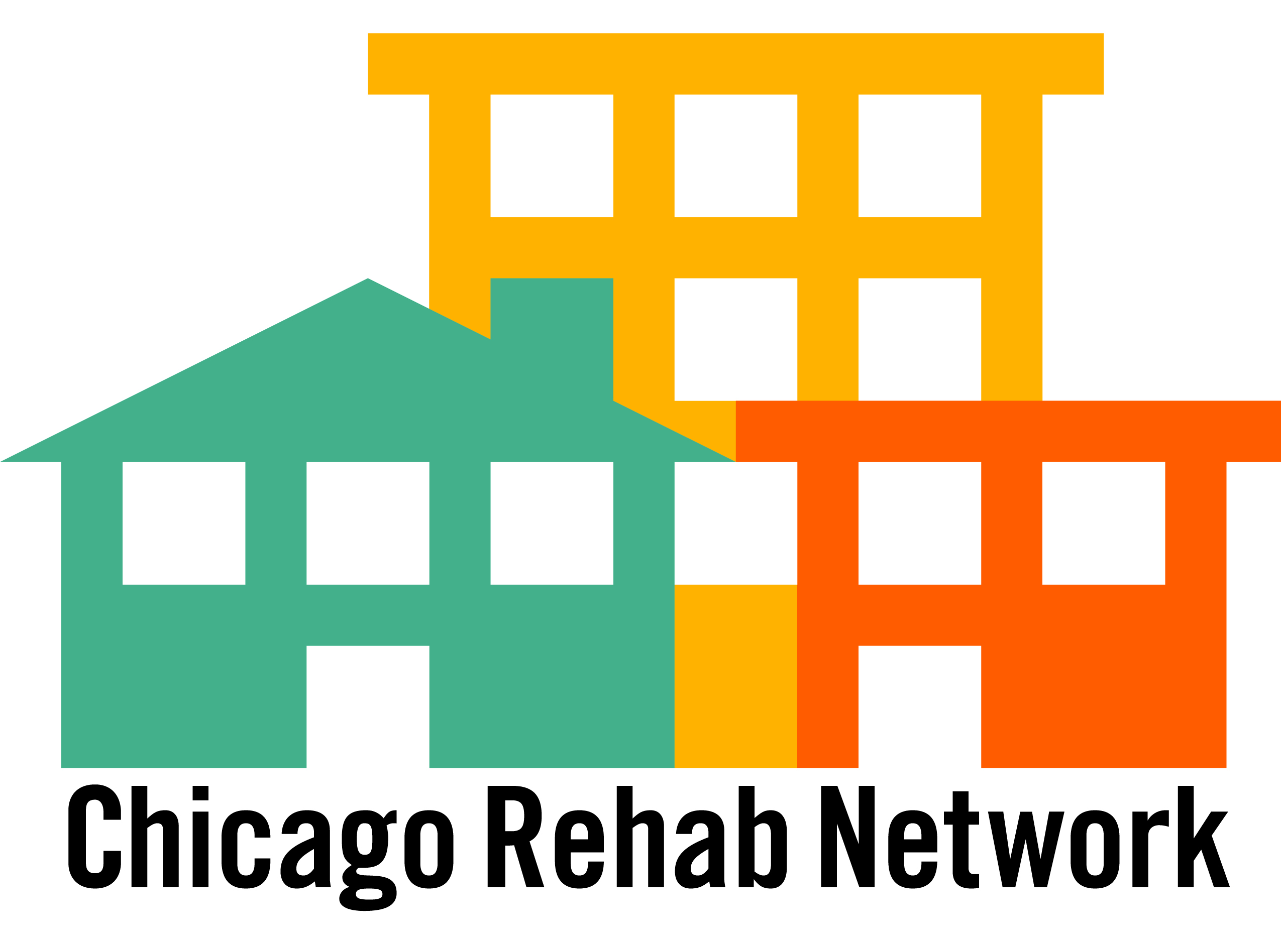

FROM: Kevin Jackson, Chicago Rehab Network

RE: Comments on the Proposed TARP – Troubled Asset Relief Program: The Potential Juncture between the Neighborhood Stabilization Program (HR 3221) Title III of the Housing and Economic Recovery Act of 2008.and the Emergency Economic Recovery Act of 2008

DATE: October 1, 2008

***********************************************************************

We are asking you to assert your leadership to ensure that a portion of the “bailout” assets and resources be dedicated through the vehicle of nonprofit community development corporations. The Congressional deliberations to rescue the financial markets are critically important to our local communities.

Prior to the widespread foreclosure and credit crisis we now face, community development corporations were working to ensure a place for housing in a market that has not been producing affordable rents or homes for purchase. Our ongoing analysis of housing cost burden – that is the relationship between income and housing costs – confirmed our grassroots knowledge that families were at-risk of instability to lack of affordable housing options. Households that spend over 35% of their income on housing costs are left with insufficient resources to cover other life expenses such as transportation, food, health and child care.

Now it is widely understood that a host of industries fed into the creation of a real estate market that was (and continues to be) out of reach for most Americans. Speculation at all levels – appraisals, lenders, builders, brokers, and Wall Street – pushed families into taking risks they might otherwise not have made. It is clear that an analysis of these past practices will be conducted at a later time by Congress in order to change the course of the future, but that time is of the essence.

We are focused on how the plan translates to local markets and communities. The $700 billion “bailout” plan is targeted at shoring up the value of homes that so many have invested in. Today we all know unequivocally that the keystone to the growing financial crisis has been lack of affordability to enable the American people to fulfill the 1949 Housing Act’s vision – a decent place to live. The only viable enterprise that has successfully met affordable housing demands are community development corporations. The challenge ahead, we believe, is to address this core issue of affordability. That is, how to fill the gap left between what the household can afford and a monthly payment that was inflated at the outset, for both renters and homeowners.

One remedy is for Congress to dedicate a portion of the assets be designated solely for distribution to nonprofit community development corporations (CDCs). Using qualified CDCs as a vehicle will ensure that a stable housing stock is rebuilt within a framework of local supply and demand. Affordability, accountability, quality standards, community input, and long term sustainability are the indicators by which mission-driven CDCs conduct their community building work. Past efforts such as the HOPE 3 and Asset Control Area programs are models that can be retooled through HUDs HOME program or another vehicle.

The experience of CDCs over the last 40 years is one of innovation in improving capital-starved markets while creating assets, local jobs, and community stability. They should be the delivery mechanism to bring these assets back to local markets rather than refueling speculation without accountability to communities.

The impact of this situation on our work in community development cannot be overstated. We are concerned that the assets we’ve built together are now threatened and we should do all that we can to mitigate this growing instability. The community development field is well-positioned to contribute capacity, commitment, and broad stakeholder relationships to a unified effort.

Significant CDBG resources are coming to Illinois and Chicago for foreclosure mitigation and recapture of foreclosed properties via the Neighborhood Stabilization Program created through HR 3221. Important to note is that this program does not create the vehicle for municipalities or subgrantees to acquire foreclosed properties in an organized fashion.

As our greatest hope is that a significant portion of these properties be protected from blight and demolition and rather be targeted for affordable housing, we believe the Troubled Asset Relief Program (TARP) will be the key vehicle for distribution of assets. Understanding that the negotiations around the Recovery Act are ongoing this week, the principle of directing these assets to nonprofit organizations should be a key part of any institution charged with the capture and sale of both multifamily and single family assets.

Further, we support both the spirit and content of the proposal of New York City’s Partnership to Preserve Affordable Housing. Their recommendations for the multifamily assets are that no action is taken to preempt the subsides or rent protections that currently exist; that these parties and local government be given priority to purchase assets; and that the TARP entity be required to sell its assets with underwriting criteria that ensure the sustainability of affordable housing regarding operating costs and rent levels.

