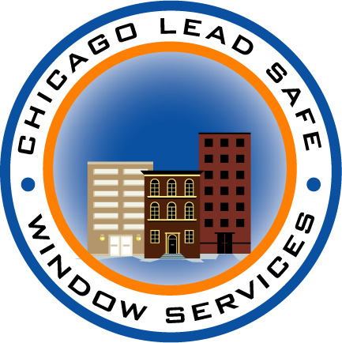FINANCIAL ASSISTANCE for LEAD ABATEMENT
IN MULTI-FAMILY APARTMENT BUILDINGS

WINDOW REPLACEMENT & LEAD ABATEMENT AT 50% OF COST

PLUS FREE WEATHERIZATION UPGRADES

Lead dust from windows is a main source of lead poisoning that is especially hazardous to young children. Chicago’s lead ordinance prohibits lead hazards in all residential property. A new City-sponsored program helps landlords avoid violations and improve energy efficiency at reduced cost.

Multi-family apartment buildings with 4 or more units may qualify for financing with 50% loan forgiveness to pay for lead abatement improvements including:
- Window & door replacement
- Aluminum capping
- Removal of cracking, flaking plaster and paint and other improvements

Financial assistance is available if:
- The building was built before 1978 and allows families with children;
- The rental rate for the majority of the units is affordableand the owner agrees to keep rental rates affordable for 7 years after the work is completed;
- The owner and building meet financing criteria for the 50% loan forgiveness.

Grant funding also pays for 100% of the cost of weatherization improvements:
- Storm Doors, weather stripping and calking
- Water heater blankets
- Low E and Argon Energy-Saving Glass

How does the 50% match work?
Chicago Lead Safe Window Services (CLSWS) has been approved by the City of Chicago’s Department of Public Health to administer the City’s incentive program. Once the City approves the scope of work, CLSWS prepares a contract for the work and financing. If financing is approved, the landlord makes regular monthly payments until 50% of the cost of the work is repaid. At this point, the other 50% of the loan is forgiven.

For more information contact Chicago Lead Safe Window Services at 312-423-3150.

www.HealthyHomesChicago.Com

In 2007, the maximum affordable rent for moderate-income households is approximately $1,490 per month.

