Conference Agenda

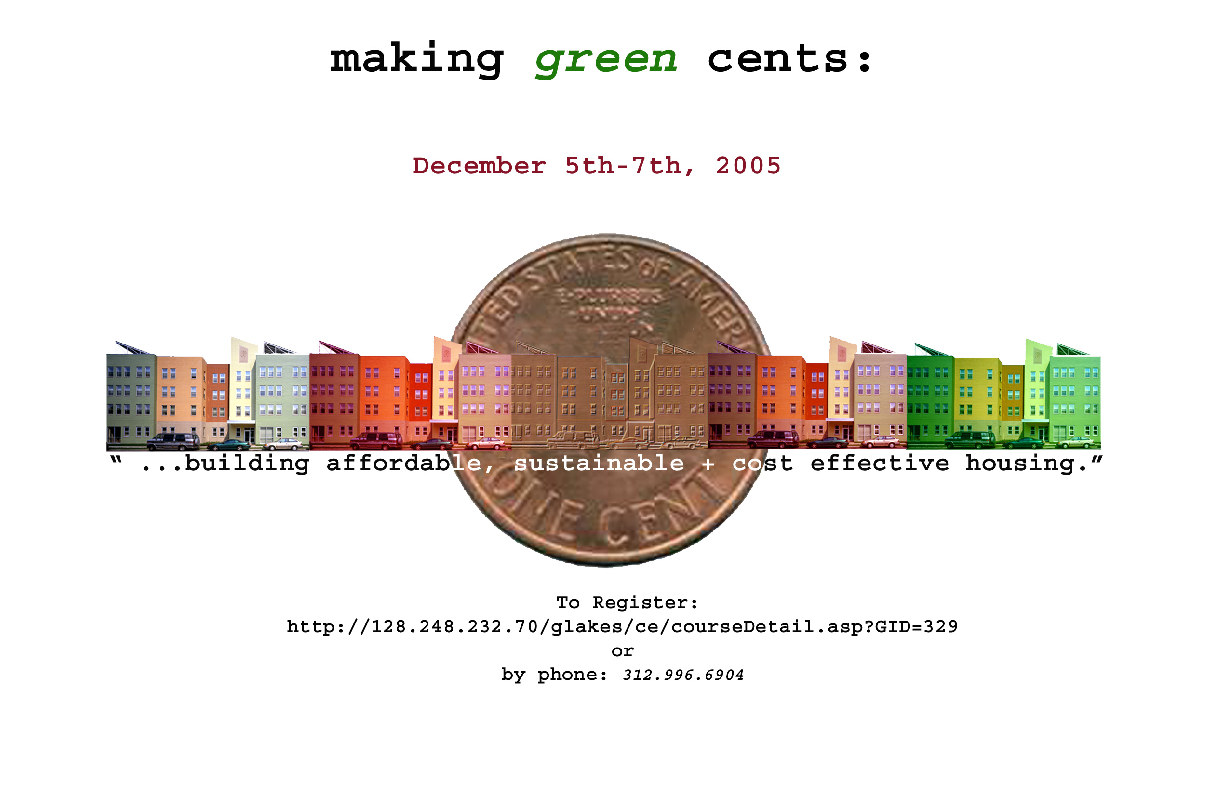

Sponsored By:

University of Illinois Chicago School of Public Health

Participating:

US Department of Housing and Urban Development (HUD)

City of Chicago Department of the Environment

Great Lakes Center (UIC)

US Environmental Protection Agency (EPA)

AIA Chicago

Illinois Department of Housing (IDHA)

City of Chicago Department of Housing (DOH)

Corporation for Supportive Housing

Chicago Mayor’s Office

Conference Dates and Location:
December 5th-6th (Monday- Tuesday).
With optional tour on December 7th (Wednesday).
77 West Jackson
3rd Floor Conference Room/ Smaller Break Out Room
Chicago IL 60010

Content / Audience:
The goal of the conference is:
- To examine real choices, real cost limits, and issues of trade-offs in green affordable housing construction.
- To encourage sustainable, cost effective, building practices in affordable multifamily housing construction.
- To eliminate barriers of uncertainty about sustainable construction for institutions that are considering green building.

The conference will be directly applicable to the 202/811 programs but also reach a larger audience including: developers, architects, consultants, non-governmental housing agencies, and non-for profits. 100 participants can be accommodated with the current space available.



Schedule
Day 1 (Monday)
8:00am Registration
Time for looking at displays
Continental Breakfast Served
9:00 am Welcome
To be announced
9:15 am Overview of Conference Goals
Introduction of Keynote Speaker
Khanh Phan, HUD Construction Analyst
9:30 am Keynote Speaker
Research on Affordable housing: Costs, trade offs and Case Studies
Bill Zoeller, Steven Winters Architects
10:30 am 15 Minute Break
10:45 am Presentation 1- Structural Insulated Panels Team
Bill Wachtler, Executive Director SIPA
Introduction to product
Case Studies
Redesign of an existing 811 building: Discussion of design considerations, costs and tradeoffs with SIP product.
11:45 pm Lunch Break
12:45 pm Presentation 2 - Precast Presentation
Marty MacIntyre, PPIW Illinois and Wisconsin
Introduction to the product
Case Studies
Redesign of an existing 202 building: Discussion of design considerations, costs and trade offs with Precast Product.
1:45 pm 15 Minute Break
2:00 pm Presentation 3- Modular and Manufactured Homes
Speaker to be announced
Introduction to product
Case Studies
Redesign of an existing building:
Discussion of design considerations, costs and tradeoffs with Modular and Manufactured homes product.
3:00 pm 15 Minute Break
3:15 pm Presentation 4- Masonry Team
Scott Conwell, International Masonry Institute
Case Studies
Redesign of an existing building: Discussion of design considerations, costs and tradeoffs with Masonry products.
4:15 pm Panel Discussion – Pros, Cons, Trade offs and Costs of Materials and Systems
Represenative from all teams discussion
Bill Zoeller, Moderator
5:15 pm Closing Remarks
5:30 pm Adjourn

Day 2 (Tuesday)
9:00 am Welcome
To be Announced
9:15 am Introduction to Day 2 Events
Introduction of Day 2 Keynote Speaker
Kelly Kennoy, City of Chicago Department of the Environment
9:30am Keynote Speaker
Sadhu Johnston, Commissioner, City of Chicago Department of Environment
10:00am Benchmarking Sustainability: LEED, Energy Star and Affordable Housing
Susan F. King, AIA, LEED AP Associate Architect, Harley Ellis
Jim Cavallo, Cavallo Associates and The Illinois Association of Energy Rates
11:00 am 15 Minute Break
11:15 am Green Renovation : Products, Strategies and Costs
Paul Knight, DOMUS Plus
Maureen Davlin, State of Illinois Dept. of Commerce and Economic Opportunity
12:15 Lunch Lunch
1:15 pm Case Studies in Sustainable Housing – Sanctuary Place
Doug Farr, Farr Associates
2:15 pm Chicago Building Code and Green Affordable Housing
Eric Oleson, City of Chicago
3:15 pm 15 Minute Break
CONCURRENT BREAK OUT SESSION
3:30 pm Large Conference Room
Other Financing for Green Affordable housing
Panelists to be announced
3:30 pm Small Conference Room
202/811 Construction Analyst Presentation
Cost Considerations in building 202/811
Examples of HUD housing
Questions on HUD construction guidelines
Khanh Phan, HUD Chicago Office
Brian Burns, HUD Chicago Office
Speakers TBA
5:00 pm Adjourn

Day 3 (Wednesday)

9:00 am Optional Tour
Sanctuary Place
Chicago Center for Green Technology
Wentworth Commons

4:30 pm Adjourn

