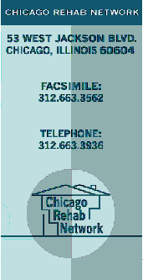
For Immediate Release

December 14, 2009

Contact: Kevin Jackson
Chicago Rehab Network
Phone: 312-663-3936
E-mail: kevin@chicagorehab.org

CRN Releases Analysis of City Housing Report

The City of Chicago Department of Community Development reports on progress of housing plan through the Third Quarter of 2009.

Today the Chicago Rehab Network presented its analysis of the Department of Community Development’s Third Quarter Progress Report on housing production to members of the City Council Committee on Housing and Real Estate. The quarterly reports are part of the City of Chicago Five Year Affordable Housing Plan, Accepting the Challenge, 2009-2013.

The full CRN analysis is available online at www.chicagorehab.org or by contacting CRN at 312-663-3936.

Also attached to CRN’s reports are the October issue of CRN’s monthly foreclosure report, A Picture of Chicago Foreclosures, and the 2009 Housing Fact Sheet.

The Chicago Rehab Network (CRN) is a citywide coalition of community-based development organizations. Founded in 1977 by community groups seeking to pool expertise and share information, the coalition membership consists of over 40 housing organizations representing over 60 city neighborhoods. Over the years CRN’s members have created tens of thousands of affordable housing units and made a visible impact on some of Chicago’s most disinvested communities, while preserving affordable housing in some of its most rapidly gentrifying ones. Visit www.chicagorehab.org for more information.

###

